EEE307 - Embedded Systems
- M.P.C.Herath - 1262

Repositoty Making Tutorial : 1
( in this pdf, I publish all the screenshots step by step )

This is my original Github account created previously.
My account user name : pasinduc
Profile URL : https://github.com/pasinduc

1.1 FAMILIARIZING WITH GITHUB

Step 1 : Create your github account
o Visit www.github.com
o Create your account with a good username as you may need to use it in your future
Work

Step 2 : Create a repository
o A repository is used to host a single project which can contain any type of data including
folders.
o Login to your github.com page
o By selecting ‘+’ and New repository
o Name of the repository “YourFirstName_HelloWorldLabs”, Use a meaningful name with
no spaces
o Add a short description. Try to describe the project in short
o Select “Initialize this repository with a README”

This is my original Github account created previously.
My account user name : pasinduc
Profile URL : https://github.com/pasinduc

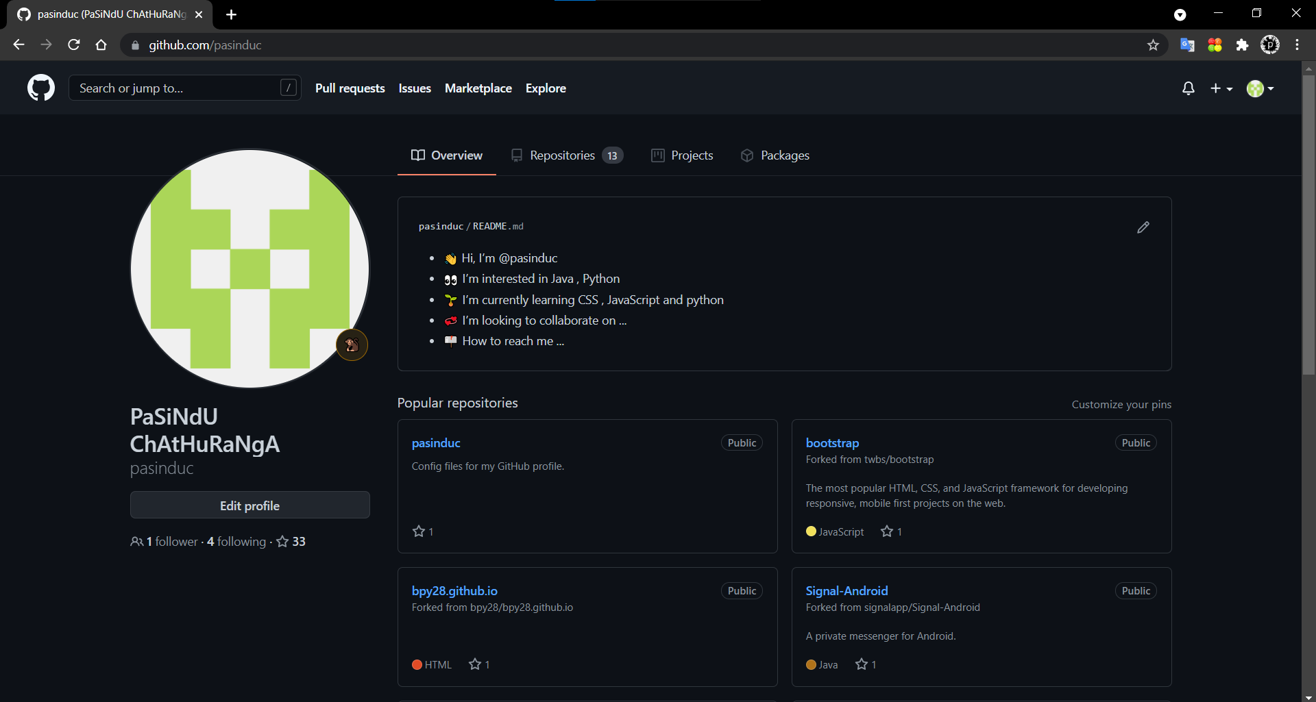

Presing + icon and select new repository

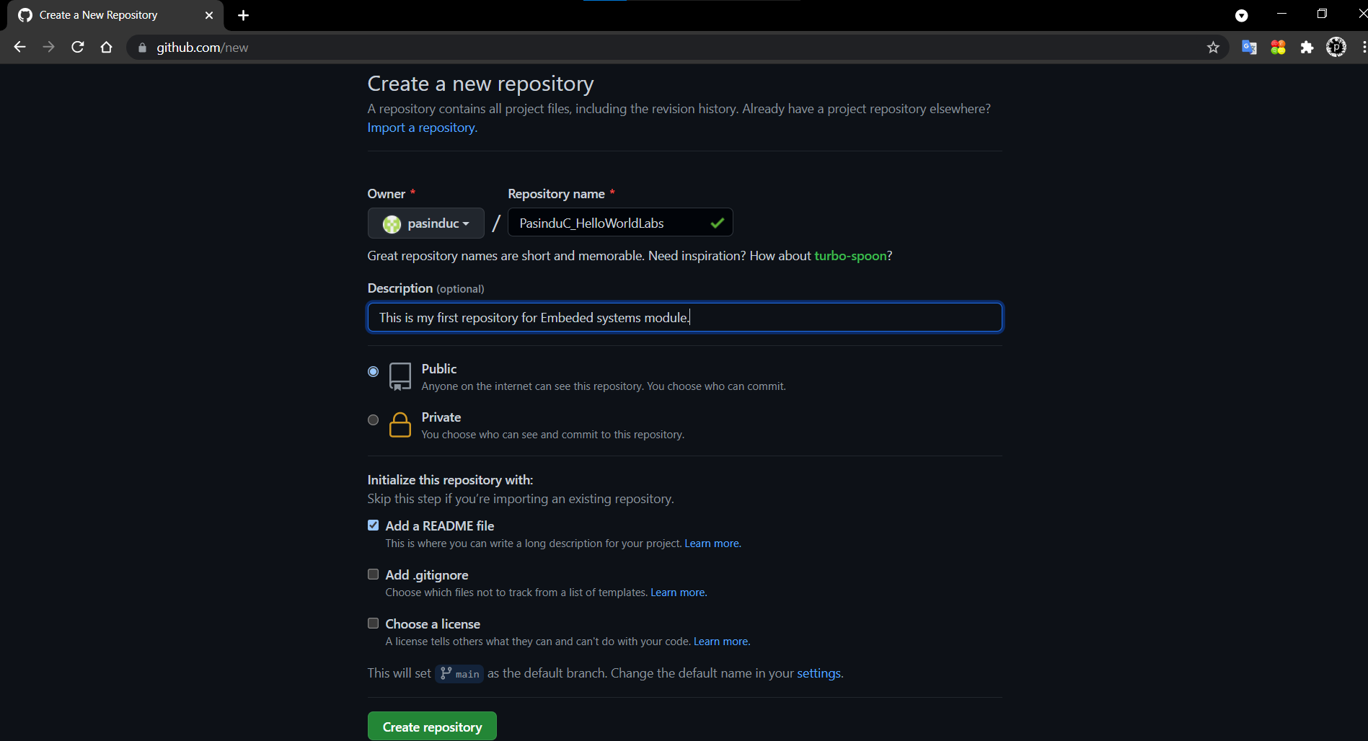

On That Repository :-

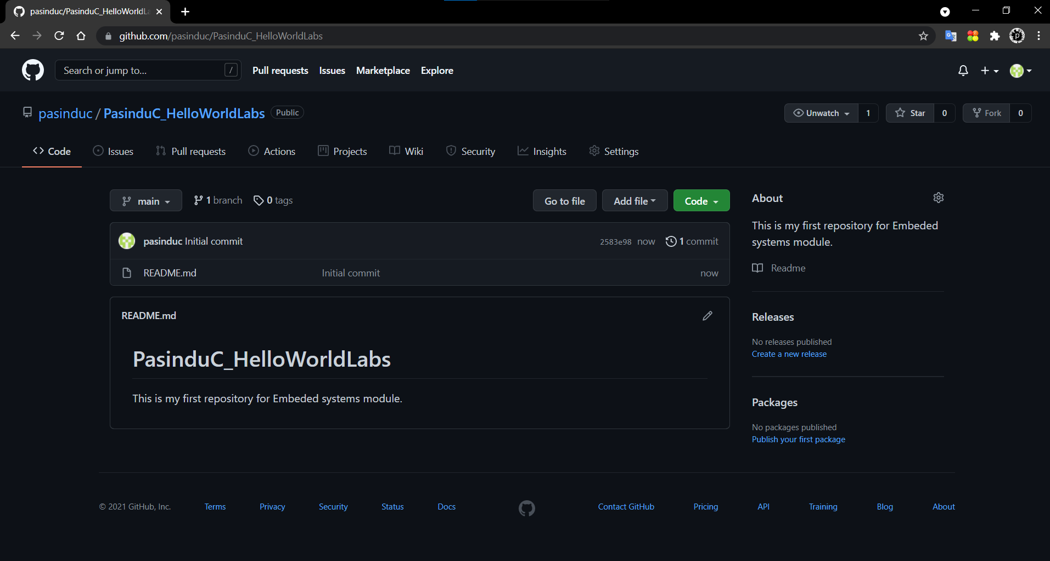

Step 3: Branching
o This is the way to work on different versions of a project.
o The master branch is considered to be the working project which can be branched,
edited and tested before committing back to the master branch. In this way master
branch contains a working set of design files all the time. Your branch is independent
from someone else’s. Therefore it is possible to work simultaneously in developing
different features of the same project.
o Create a new branch named “HelloWorld-Initial”
o Now we have two branches named “master “ and “HelloWorld-Initial”

I created a another branch named “HelloWorld-Initial” and now I have 2 branches

- Main
- HelloWorld-Initial

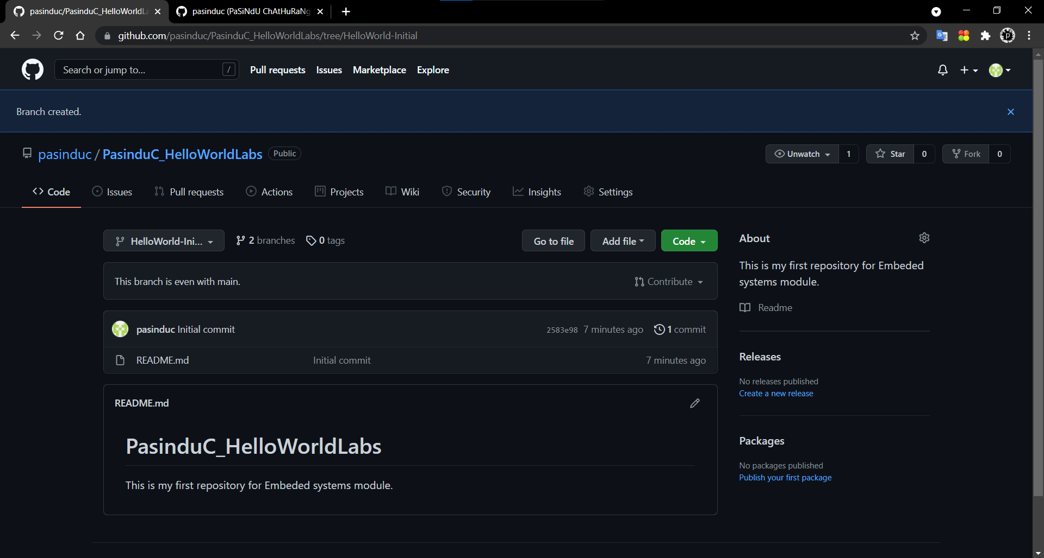
Step 4: Commit changes

o Now you can start editing the files in your branch
o Add a new file named “HelloWorld.txt”
o Write some text in the “HelloWorld.txt”
o Then click “Commit changes”

Go add file and select create new file
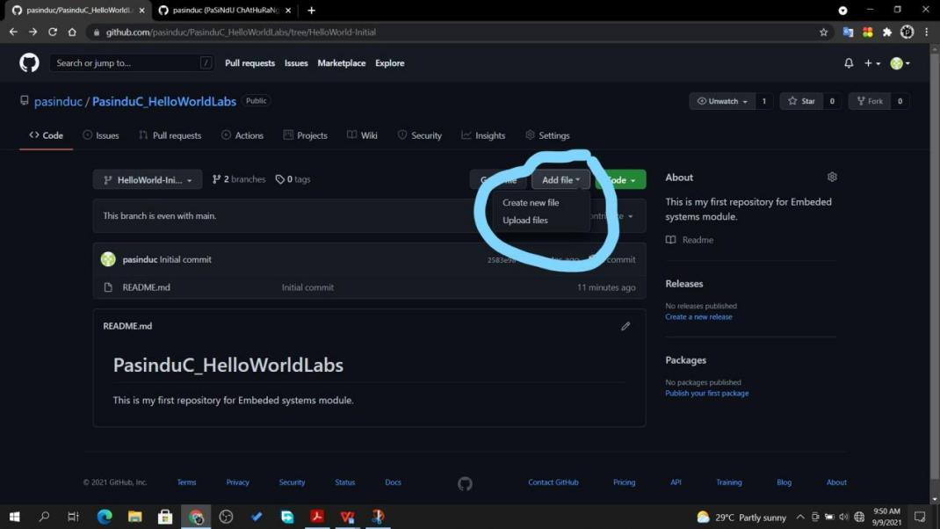

Naming that file.

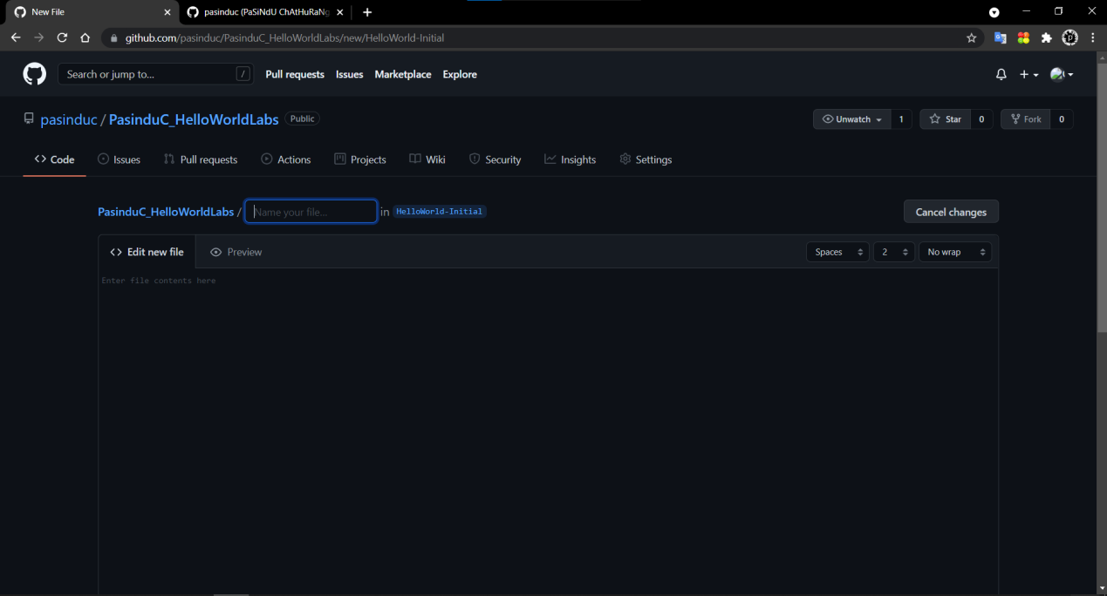

Name that file with given name “ HelloWorld.txt “

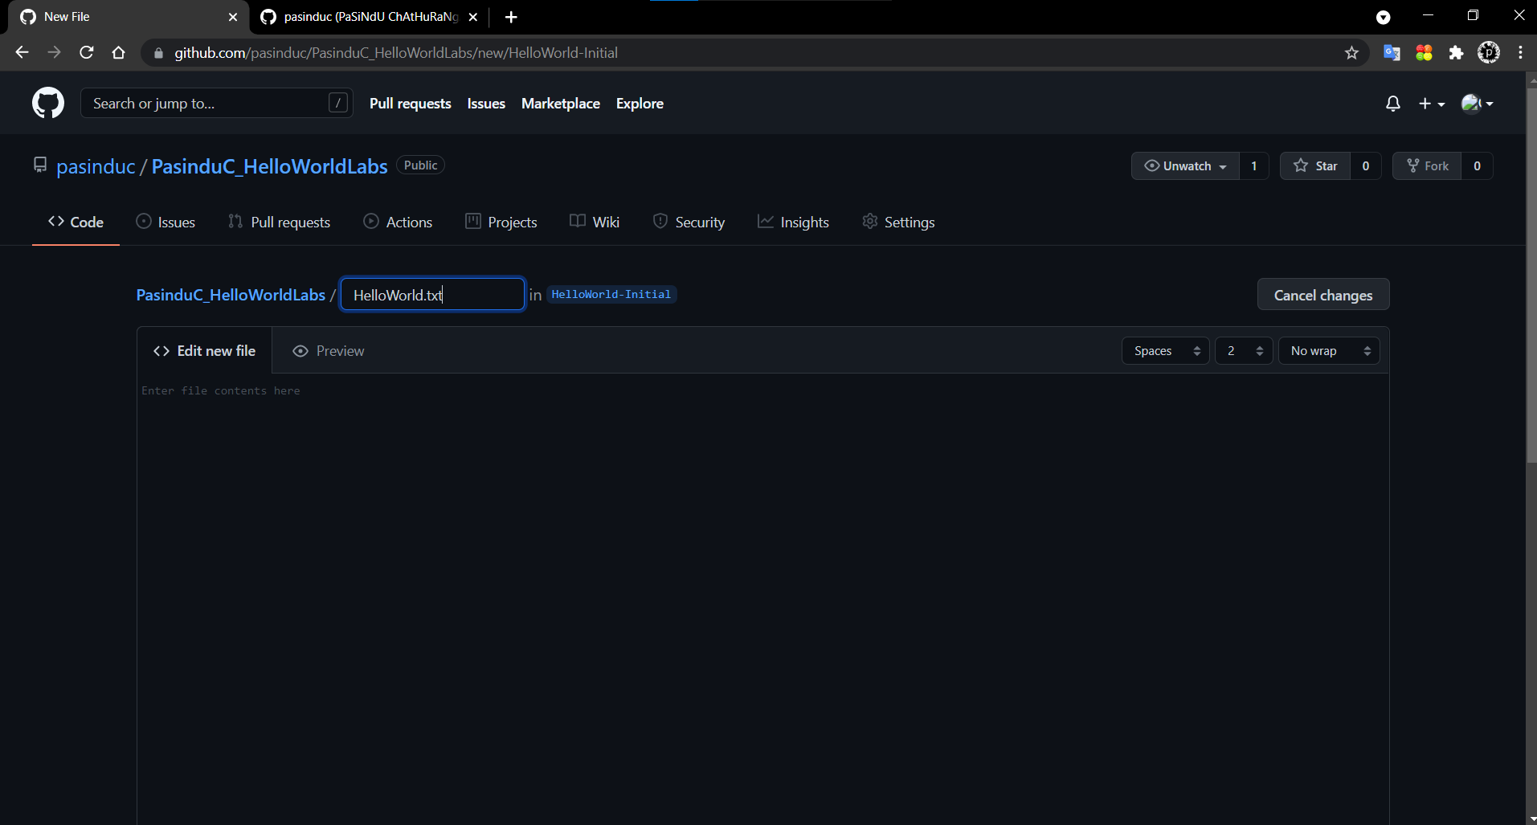

And Finished.

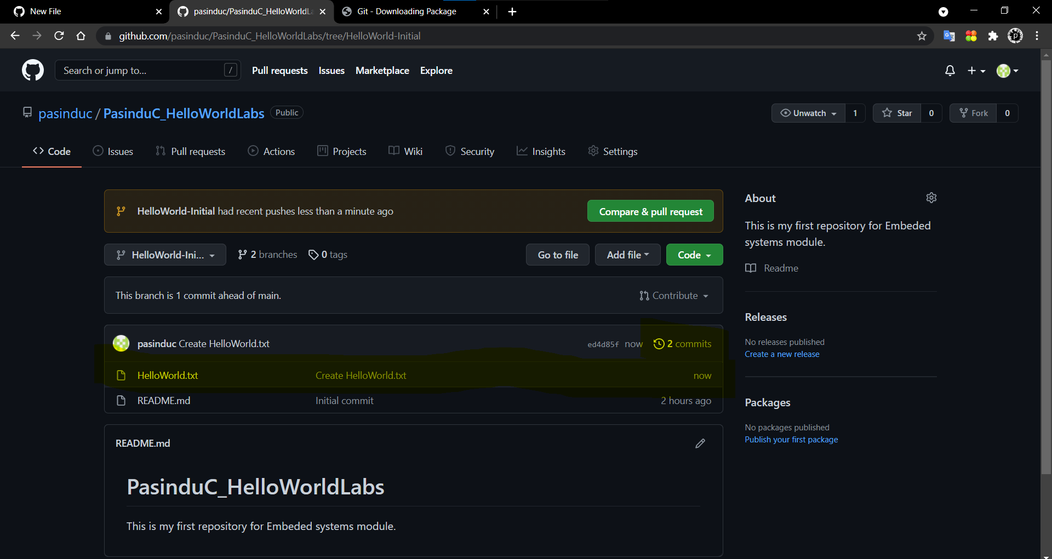

Step 5: Open a pull request
o Using pull requests, you can ask someone to review your contributions before merge
them to the master branch or some other branch.
o It is possible open a pull request as soon as you make a commit.
o You can use “mention” system to ask someone to give feedback
o It is possible to open up pull requests yourself and merge them yourself.
o Create a pull request and give it the title “HelloWorld.asm created”

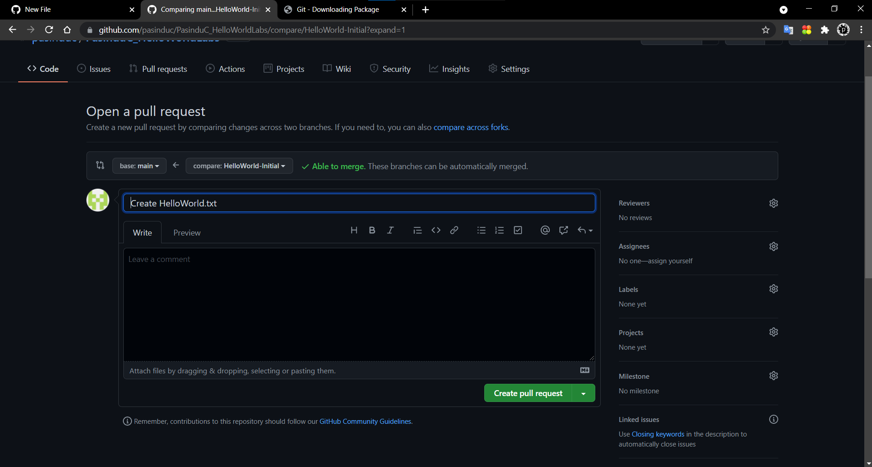

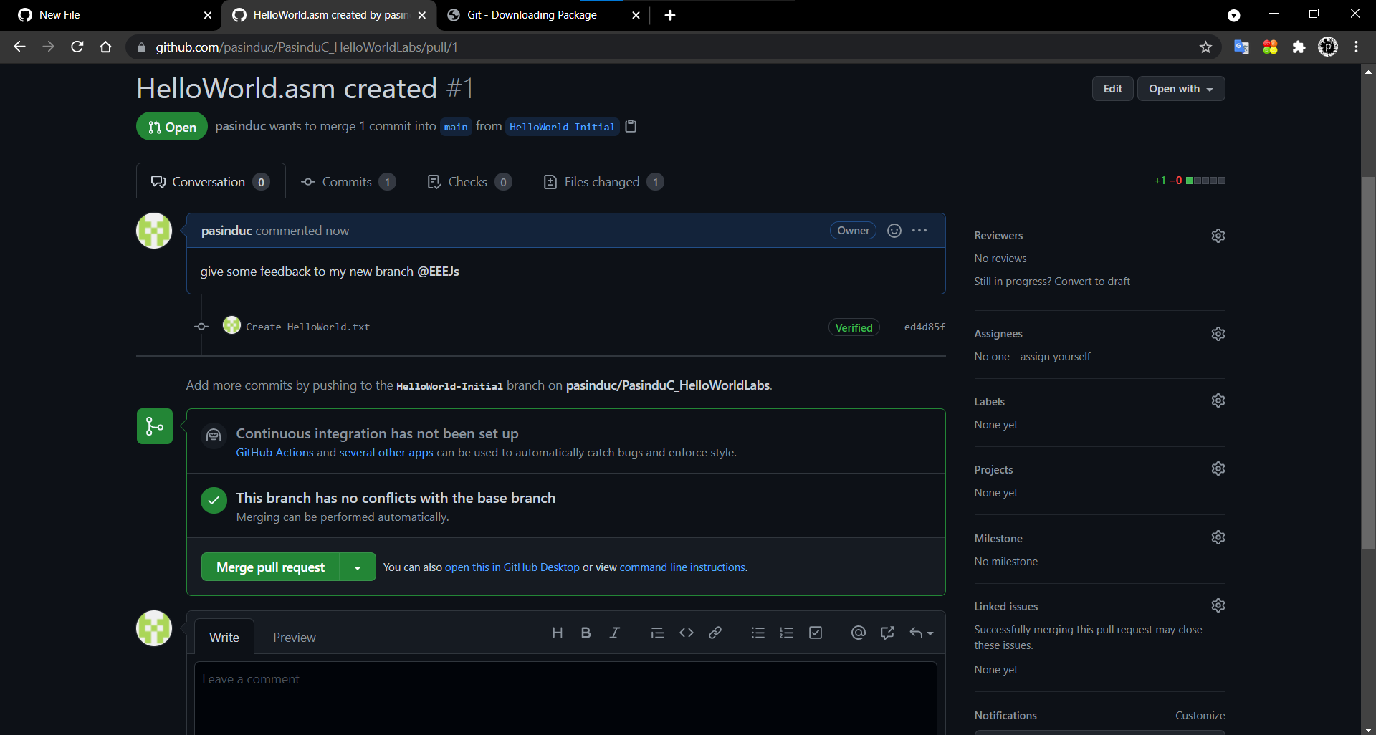

Step 6: Merge the pull request

o Once you finish testing your branch it can be merged to the master branch

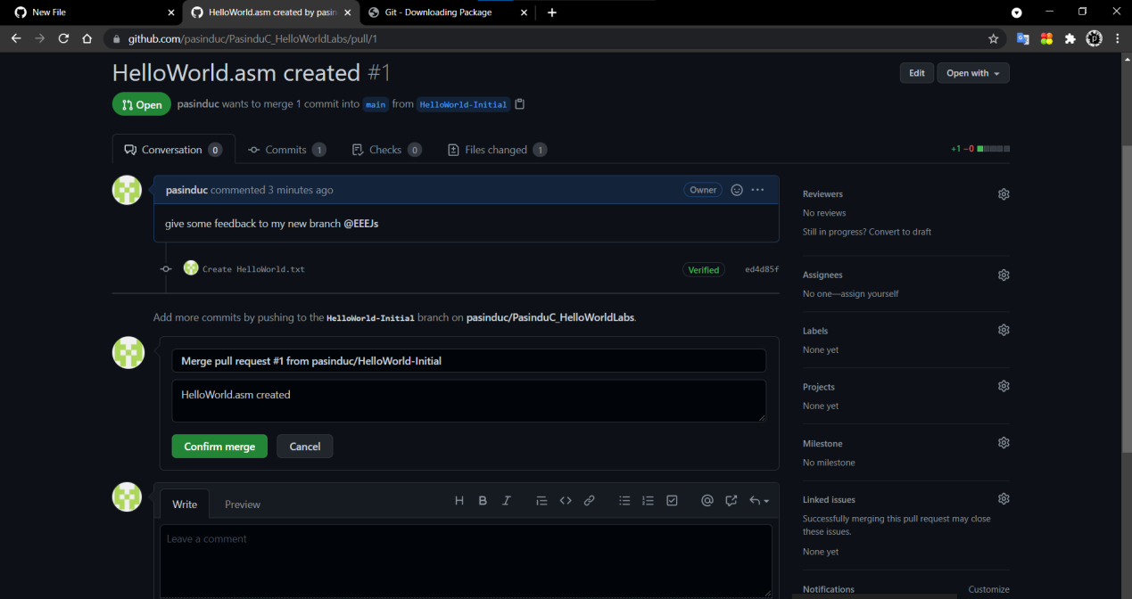

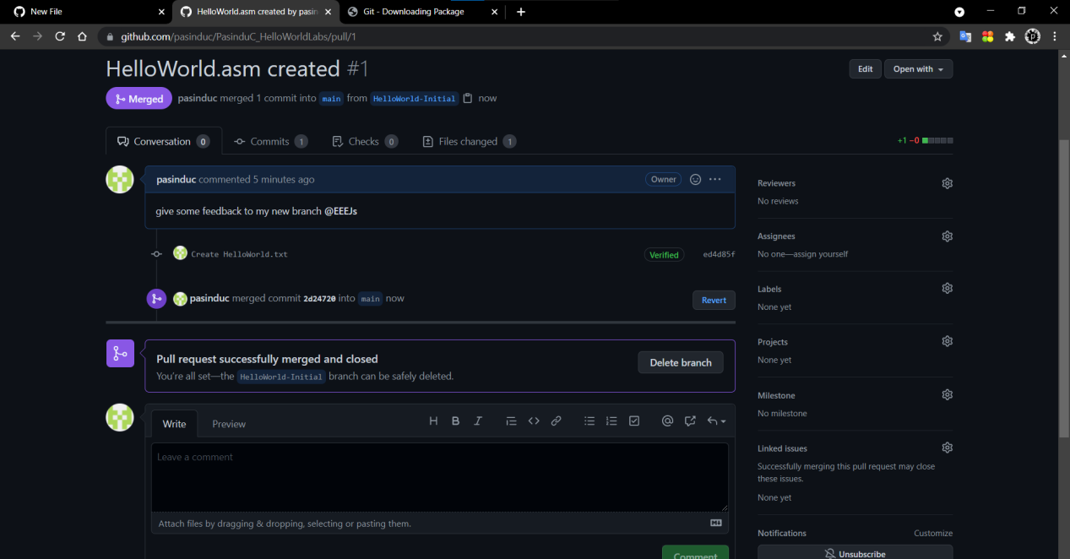

1.2 GITHUB GUI
You can manage your codes locally with the help of command line arguments or with the Github GUI.
Following instructions are to setup the Github GUI in your computer.

- Step 1 : Installing Github desktop
  - https://desktop.github.com/ download and install Github desktop from here
  - Login using your Github account login details
- Step 2 : Managing the repository
  - Clone the repository your created at Github.com to your computer
  - Now view the repository in file explorer
  - Create the following folder structure in your github folder
    - HelloWorld
      - verilog
        - doc
        - test
        - bit
  - Advantage of having a well-defined folder structure your project is that you don’t need to look again and again where some specific files are.
    - C: contains the main files, in this case HelloWorld.asm
    - Doc : Readme files on how to run the program
    - Test : A program or software simulation files which used to test your code
    - bit : bit file ready to be programmed on the FPGA
  - Now drop the HelloWorld.txt file inside the c folder.
  - Create some text files inside other folders as well
  - Now on the GUI you can see these added files
  - It shows that we have moved the HelloWorld.txt file
Figure 1 : Github GUI Changes
  - Add a “Summary” – Moved HelloWorld.txt file to the C folder
  - Now Commit to the Current branch
Figure 2 : Commit in Github desktop
  - Click push origin to upload these changes to your online repository.
  - You can make a Pull request which will take you to the online repo from the Github desktop. Create your pull request as given in the first section.
Figure 3 : Pull request
- Step 3 : Familiar yourself with Github desktop
  - https://help.github.com/en/desktop Please refer to the help located in the given link to overcome any issue you face.
  - Also try to use the other features available in the GUI. Get familiarize with them.

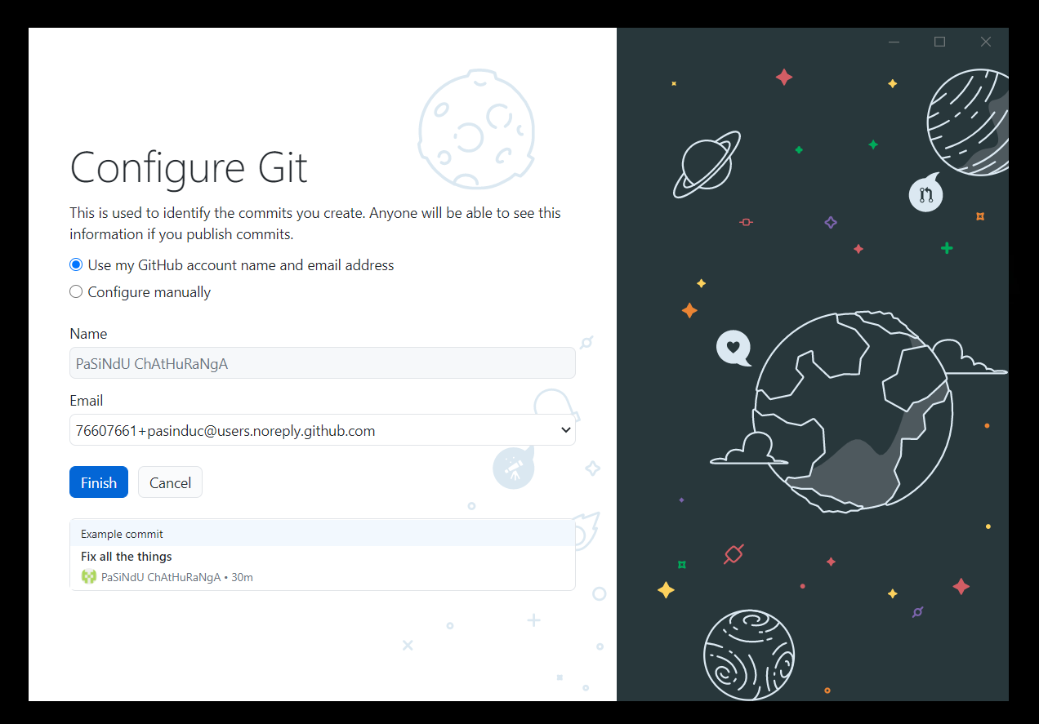

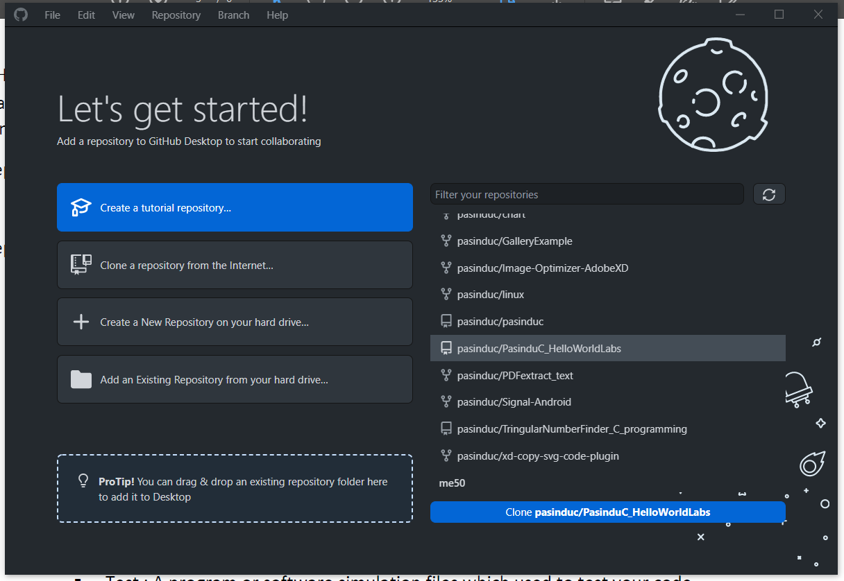

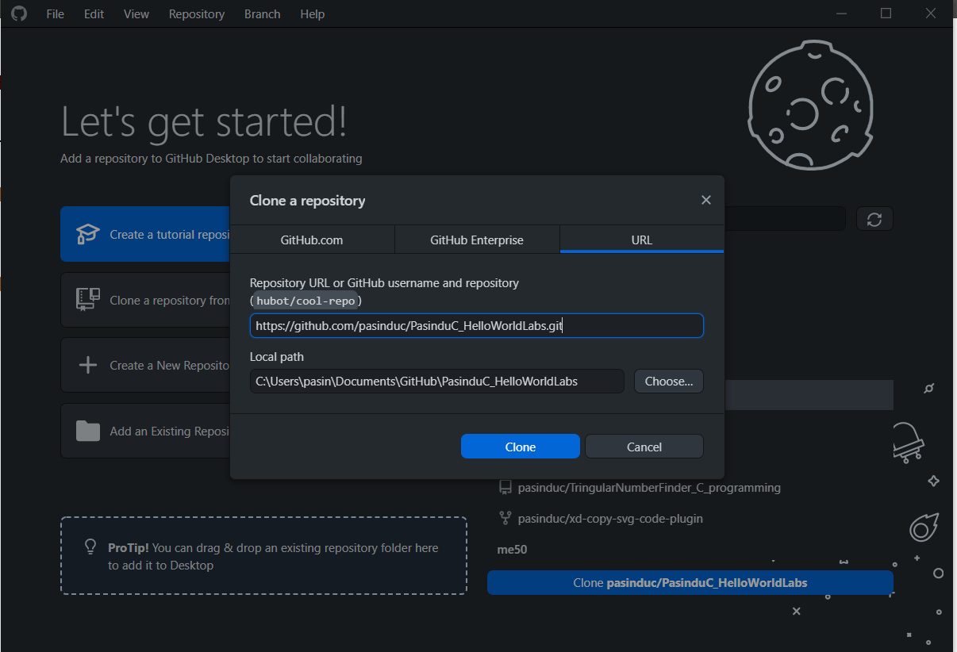

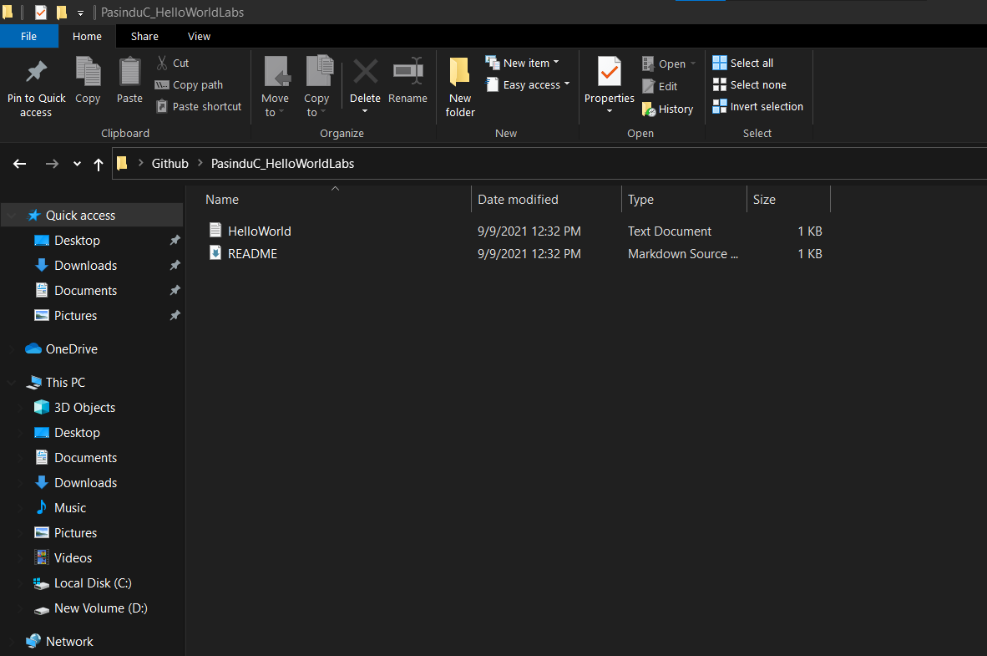

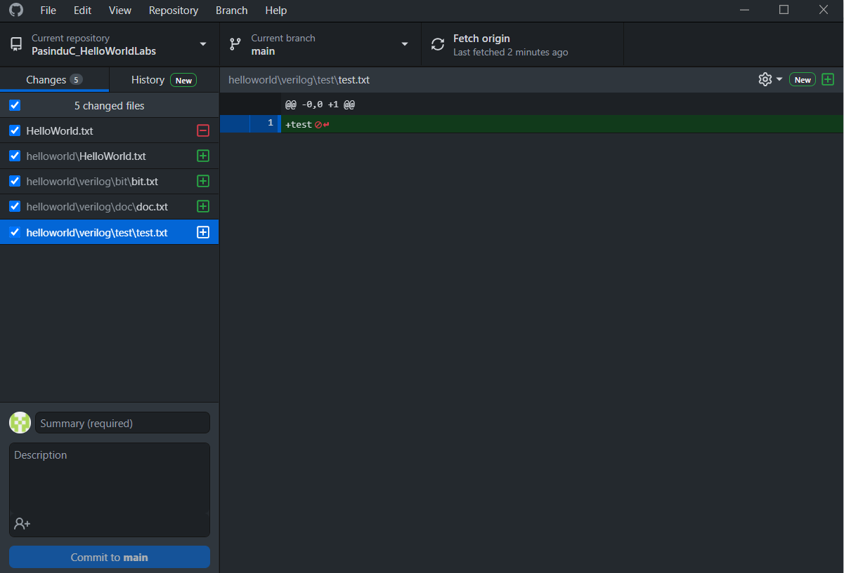

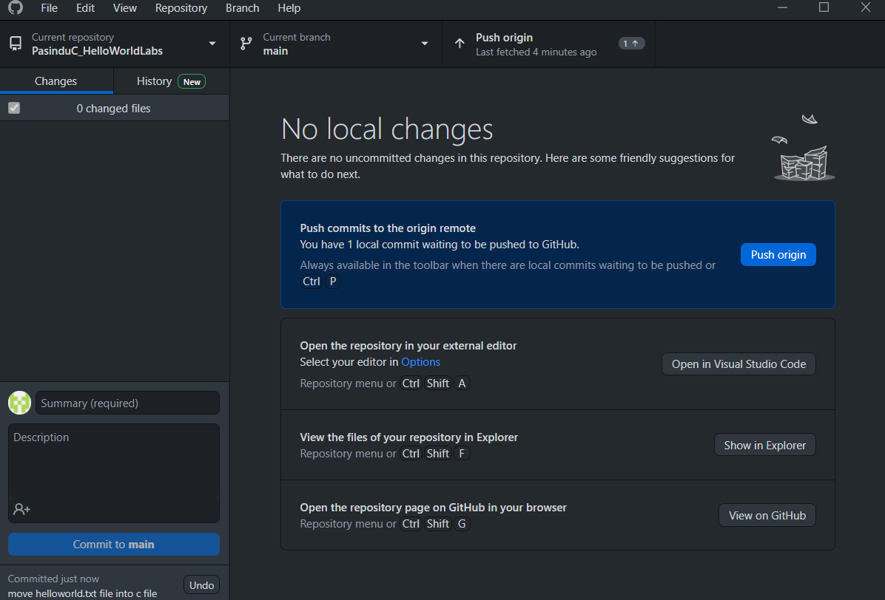

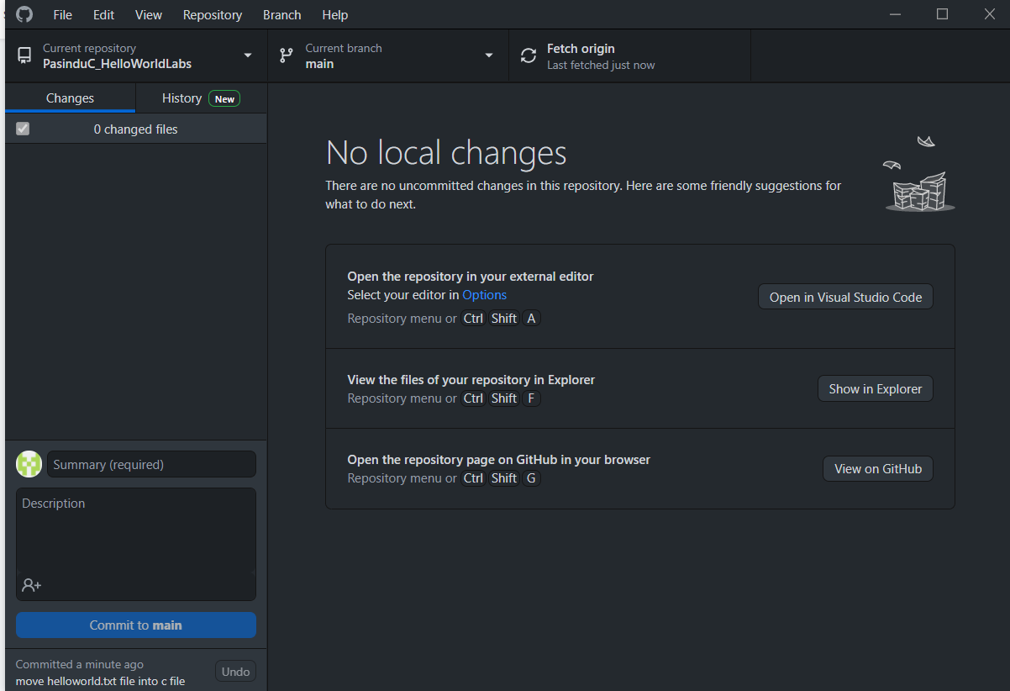

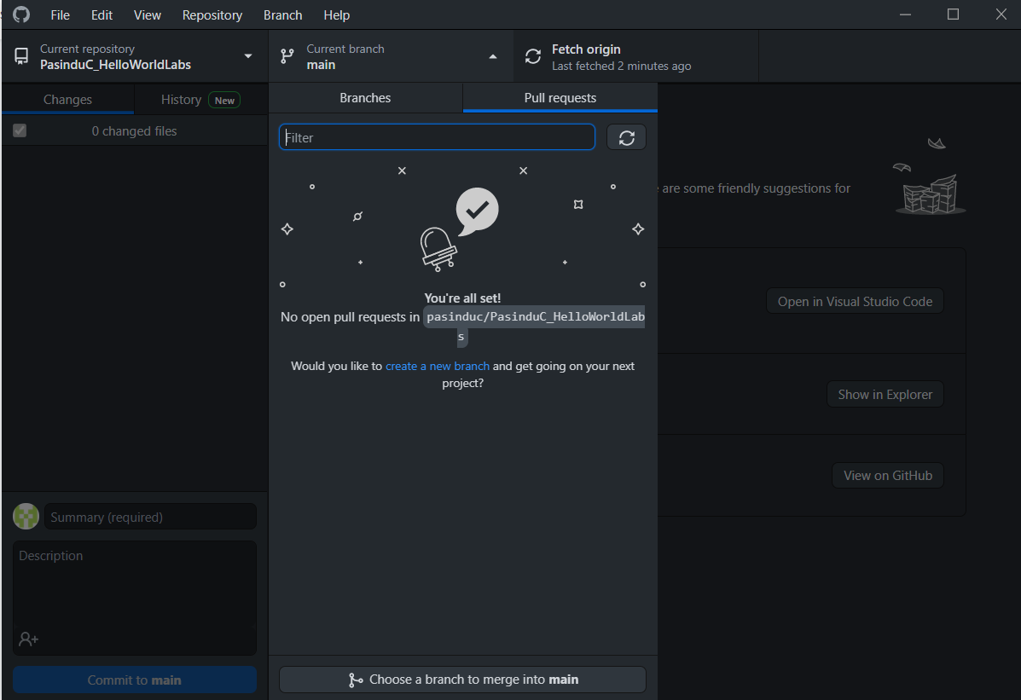

HelloWorldLab CLI : gh repo clone pasinduc/PasinduC_HelloWorldLabs
Repository Url : https://github.com/pasinduc/PasinduC_HelloWorldLabs

1.3 COLLABORATION

Main advantage of Git repo is the possibility of working simultaneously on different parts of a project.

Follow the steps to create your own repo to be shared between team members.

Step 1: Creation of new repository
o Create a public repo for your group project
o Use a shortened name as the repository name
o Create this repository without any files by the group leader

Create new repository called HLAB

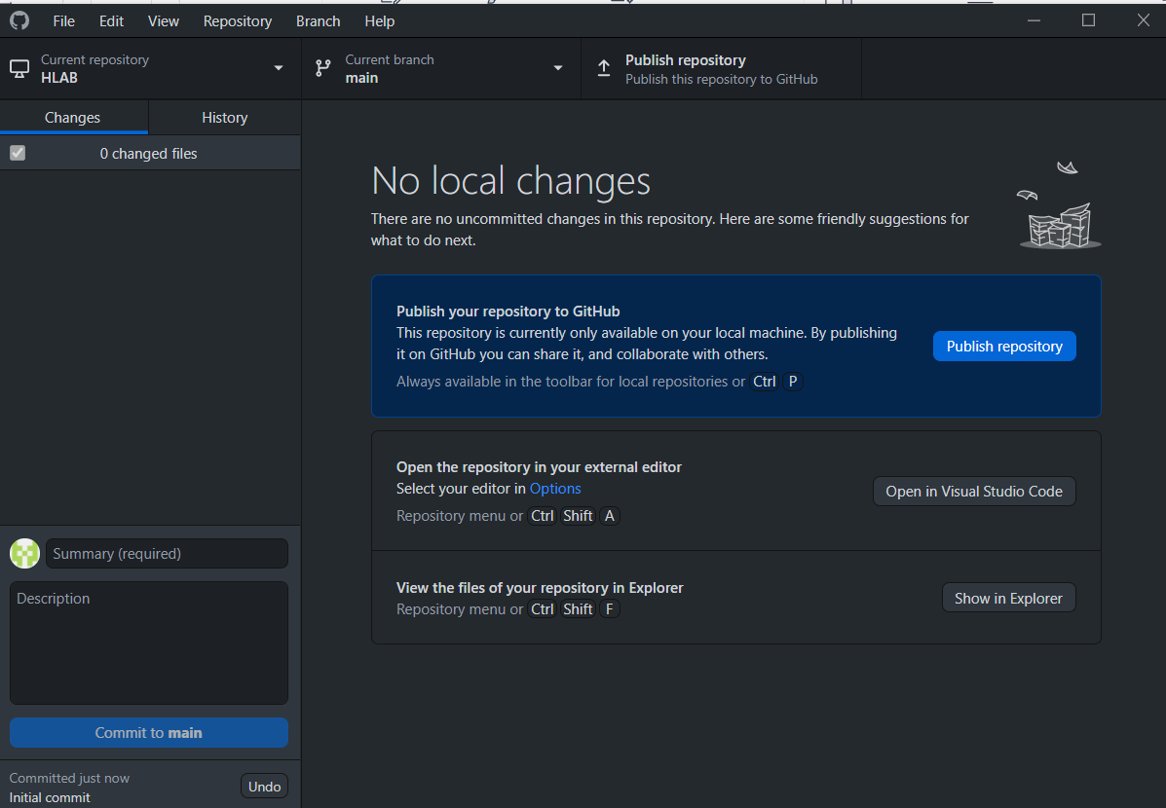

Publish the repository

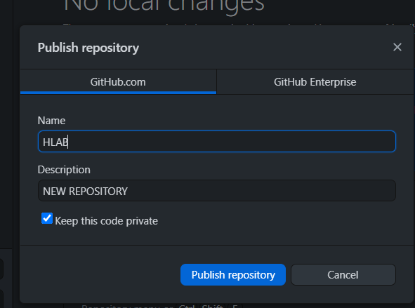

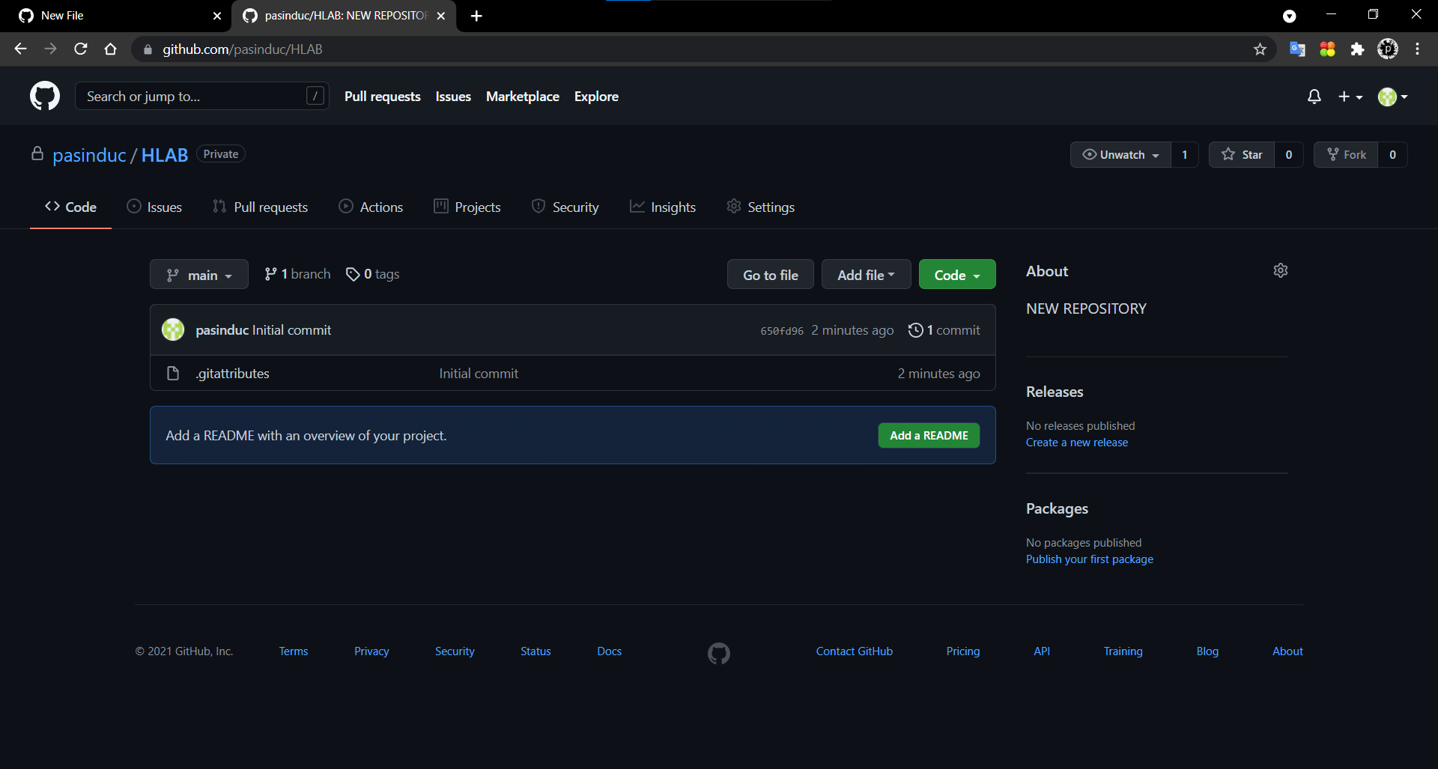

Step 2: Collaboration

o Now under the created repo goto Settings and select Manage access from the left
sidebar
o Now under Invite a collaborator, add your team members.
o Send the copied invitation link from the icon next to pending invite to your team
members.
o Team members can now accept the invitation to collaborate for the project

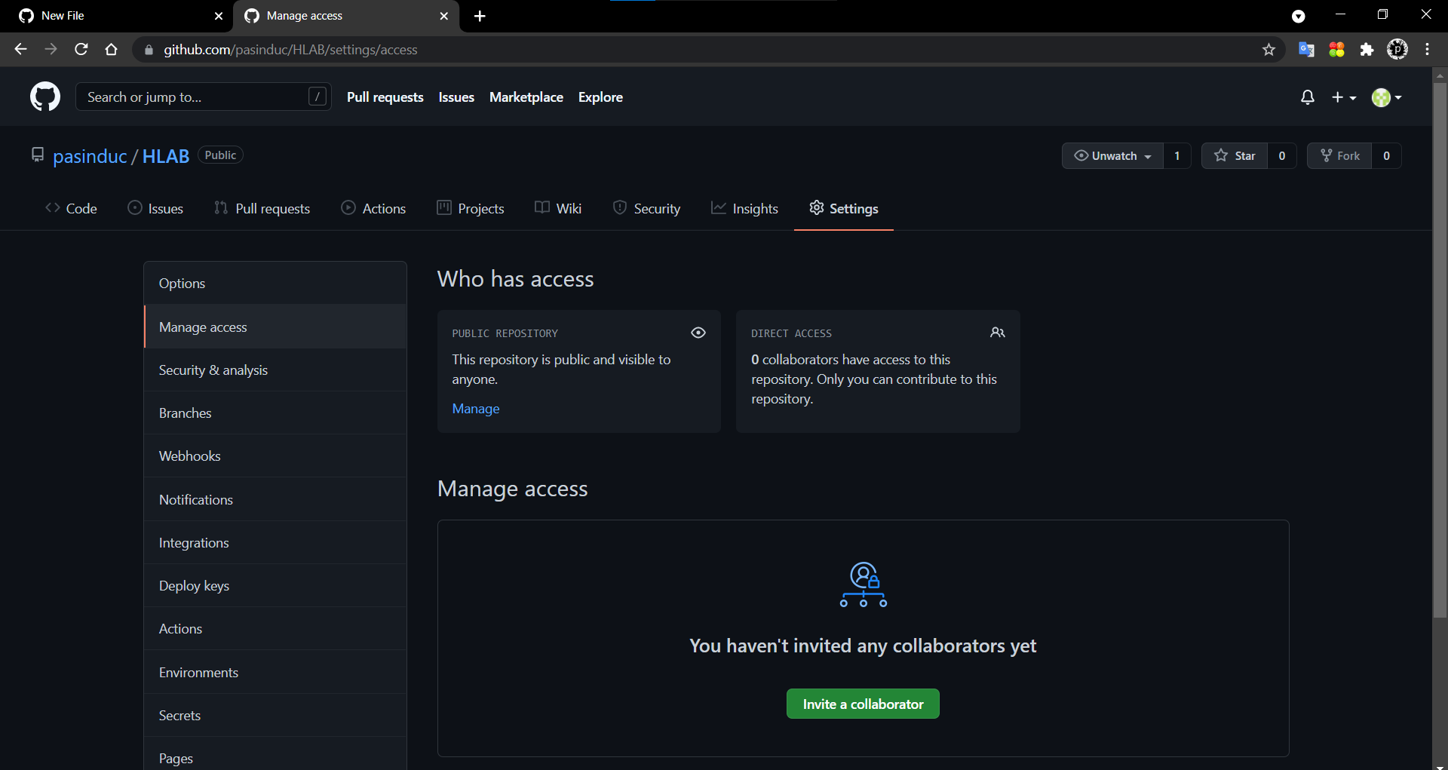

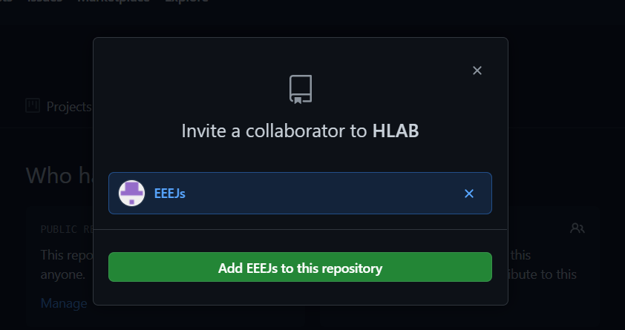

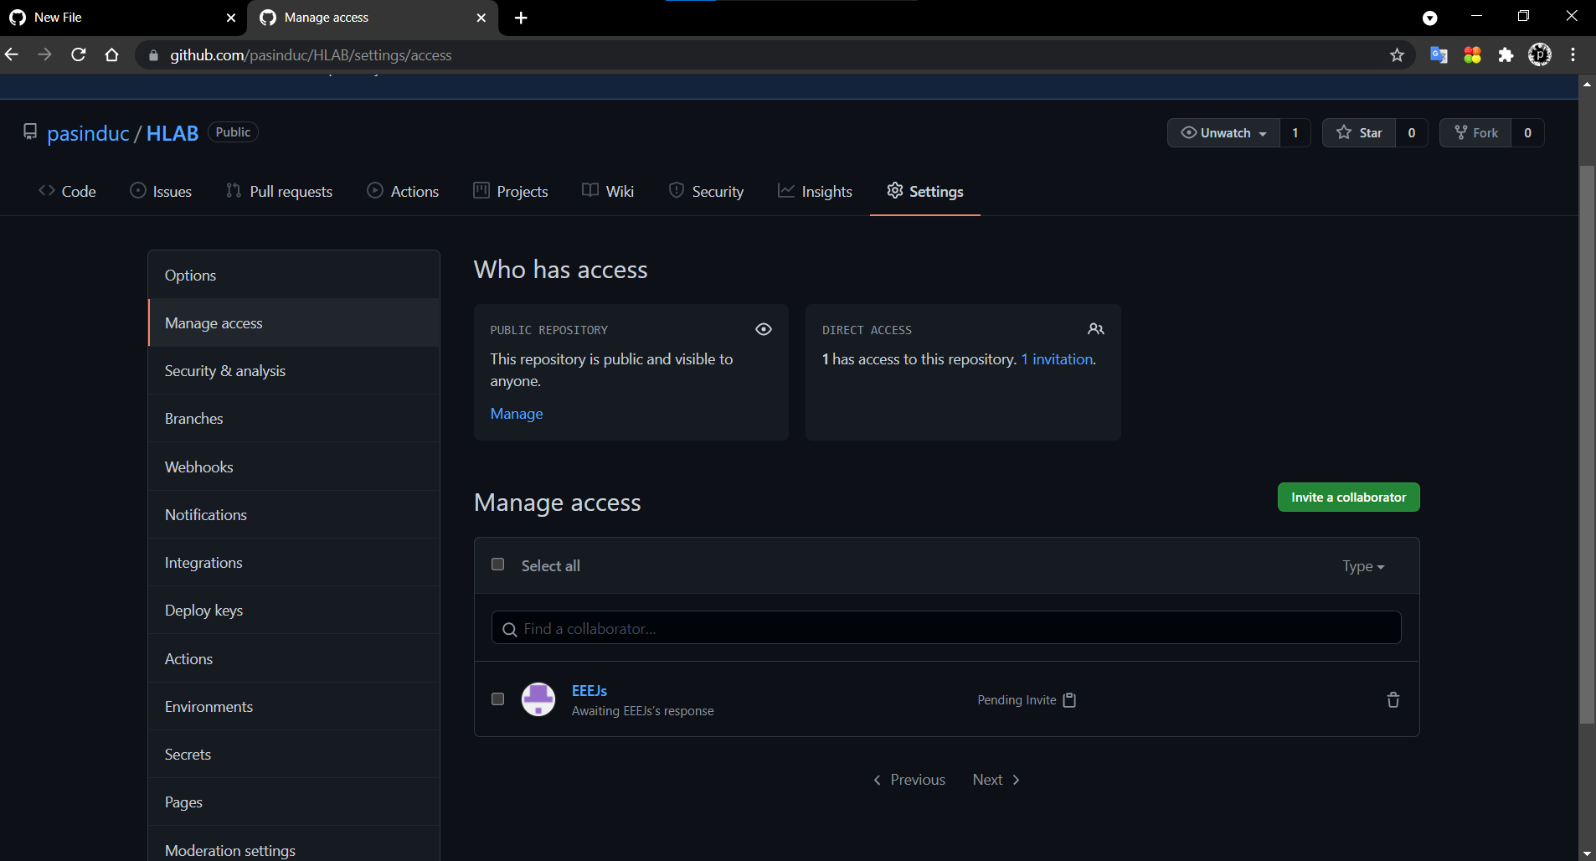

Step 3: Project setup

o Please make sure to create a branch from the master. NEVR MAKE CHANGES TO THE
MASTER.
o Distribute different possible modules among team members. Eg: 4:1 mux, 4-bit
adder…etc.
o Create a branch with a title like “SubProjectName-‘yourfirstname’”, like that create
different branch among team members
o Now create the folder structure for your chosen module. Module name is preferred to
be short yet descriptive.
o Create some text files inside the folders.

….……………………………………………..

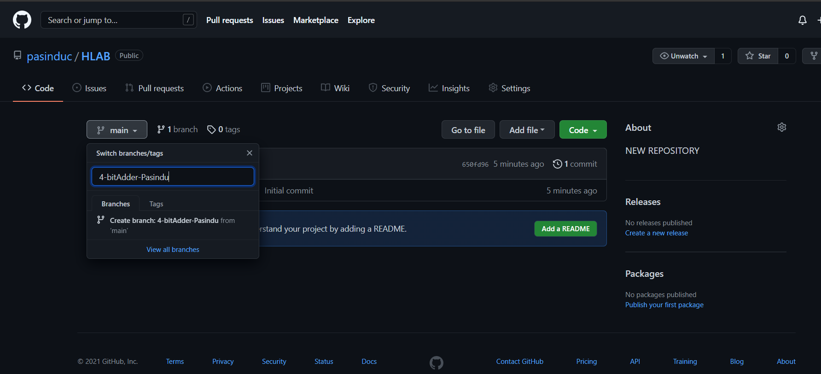

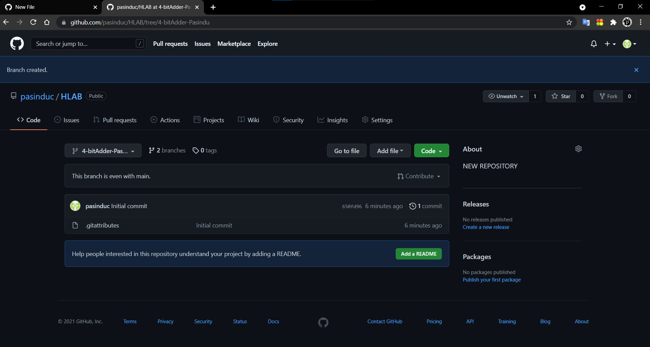

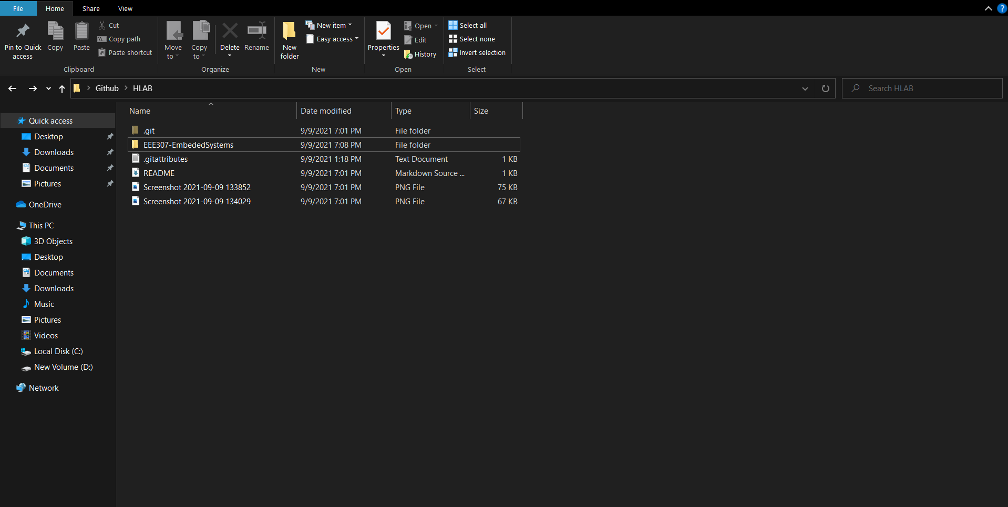

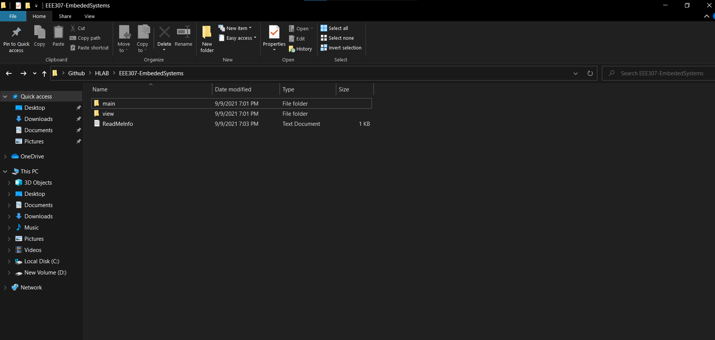

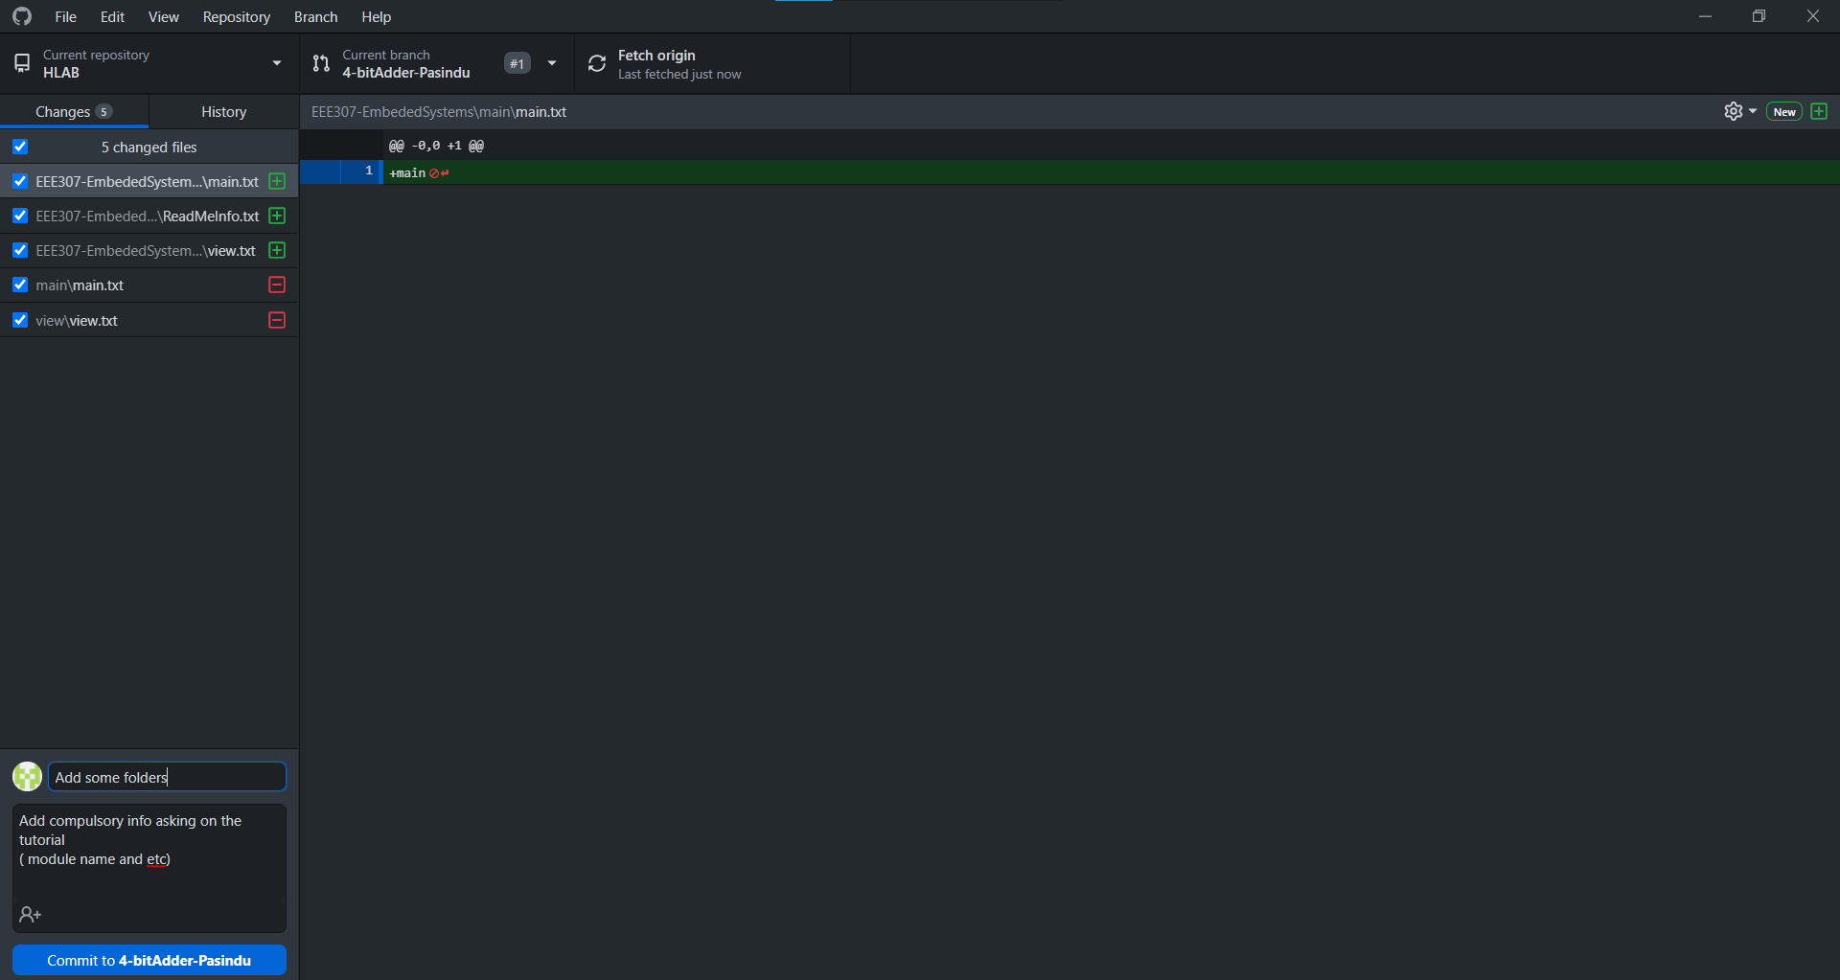

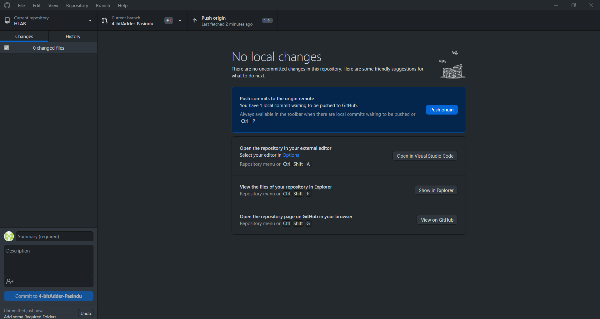
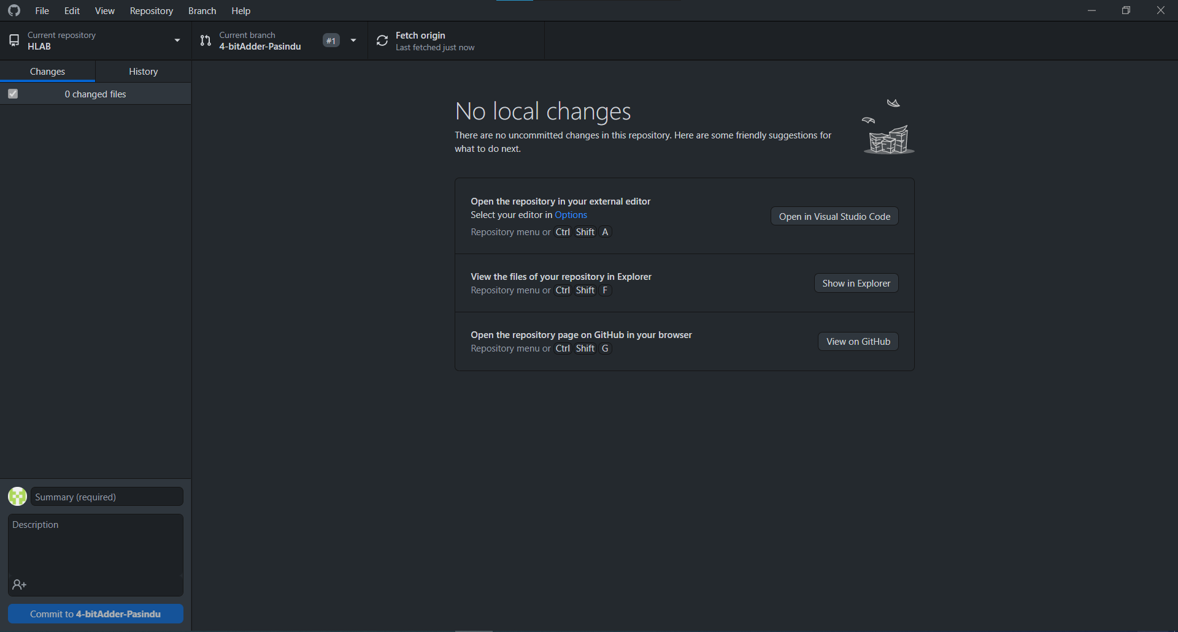

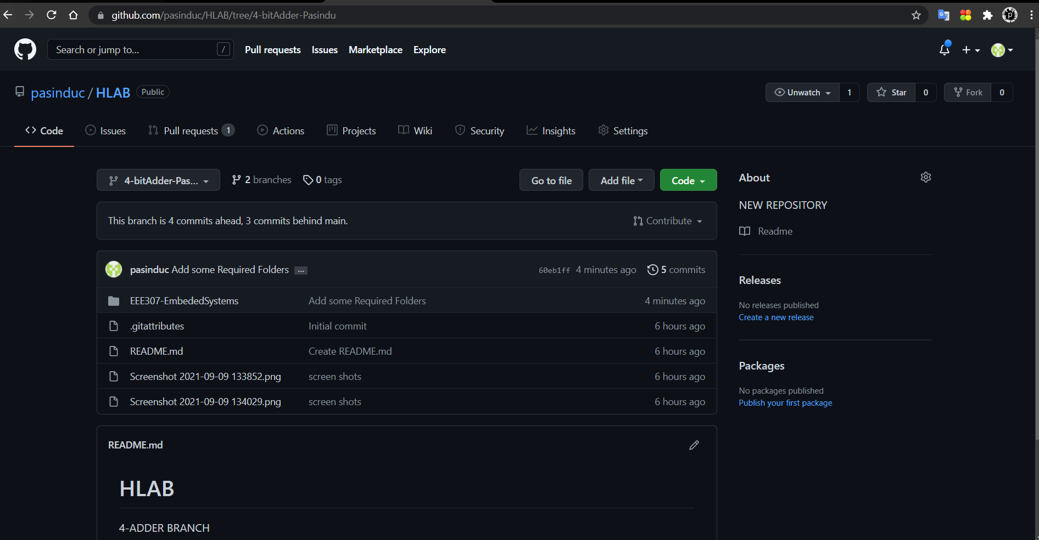

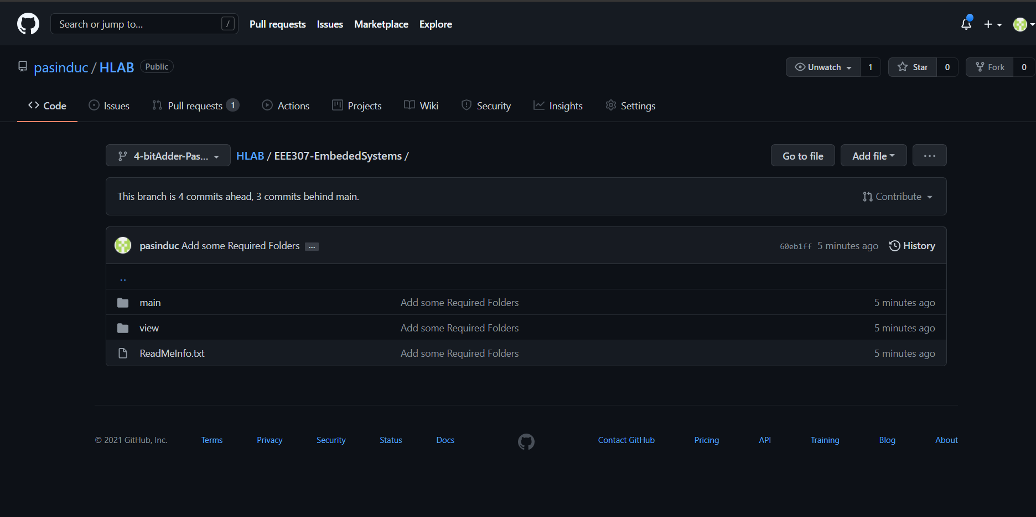

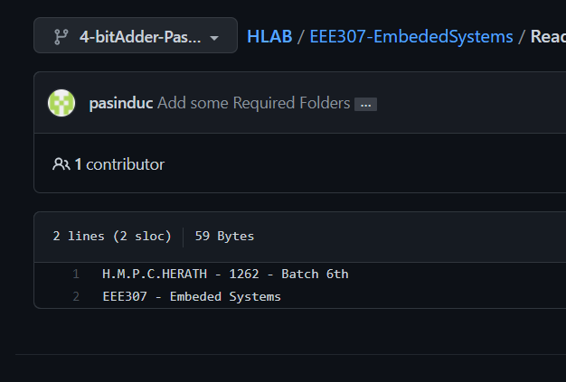

Step 4:

o Commit your changes and create pull requests. Make sure to give a short description of
the change you have done in the commit message.
Figure 5: Project collaboration
o Now the team leader can accept the pull requests if these changes are ok.
o Once accepted check the master branch and observe the differences

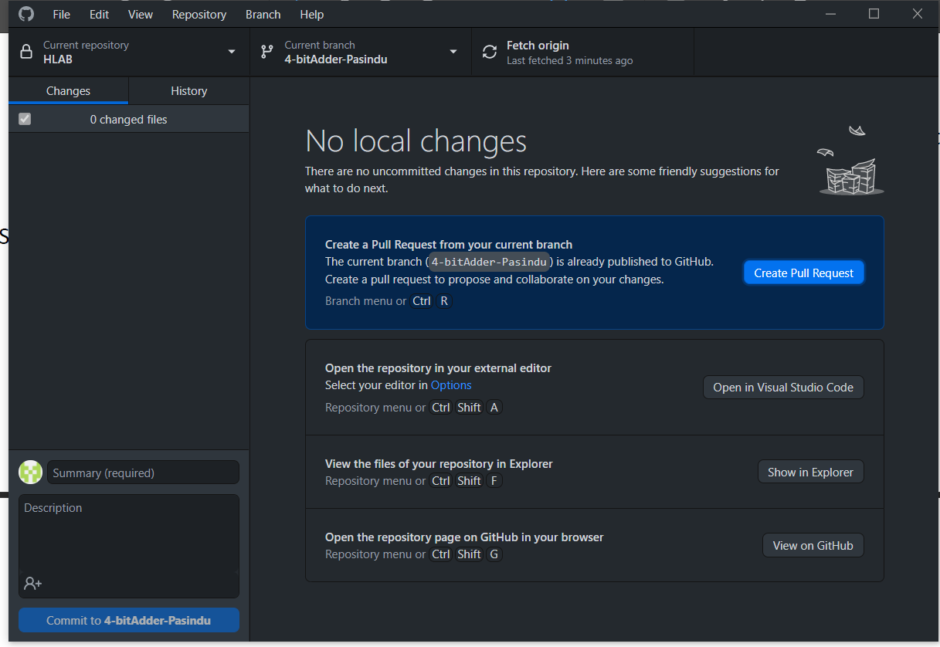

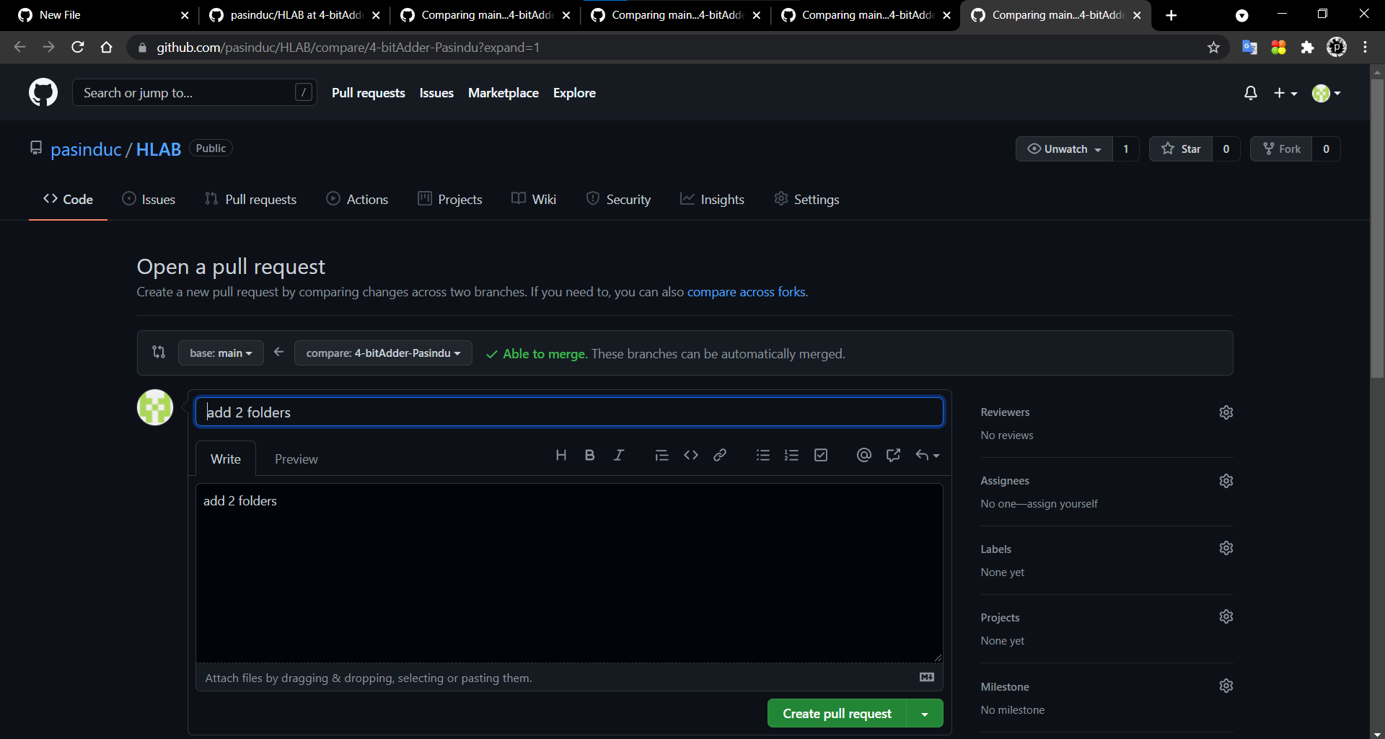

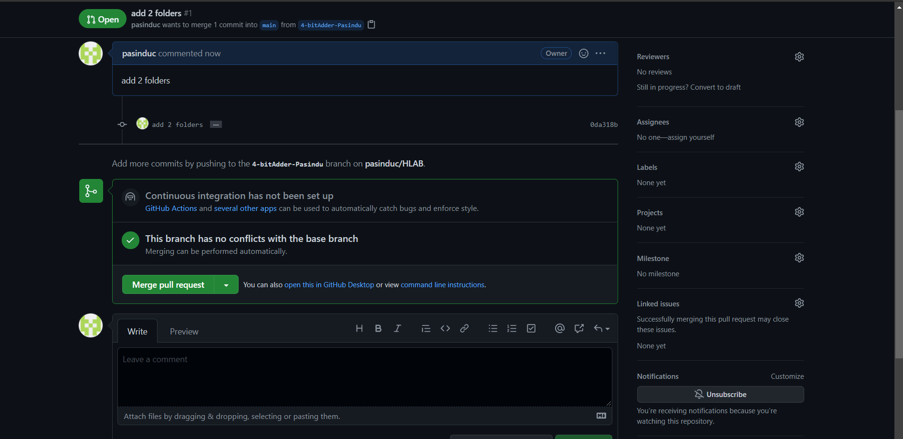

1.4 TASKS

1. Add “ishara0925” as a collaborator to your CLEAN project repository. This repository is the one
you are going to use for your project.
2. Add screen shots of the repository folder structure to your project presentation. Project
presentation should be present inside the presentation folder in your project folder.
3.Add a short description of your project under the repository description.

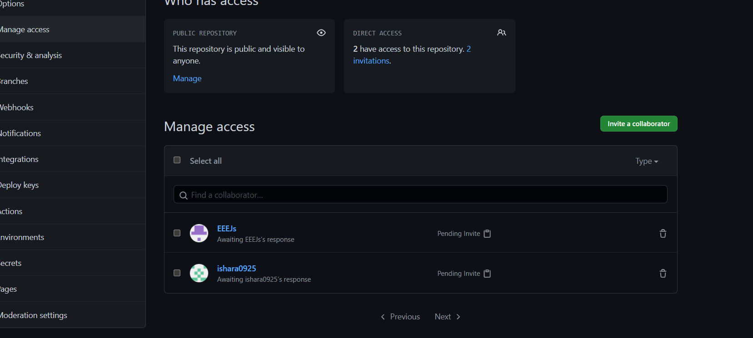

“4-bitadder-pasindu” branch
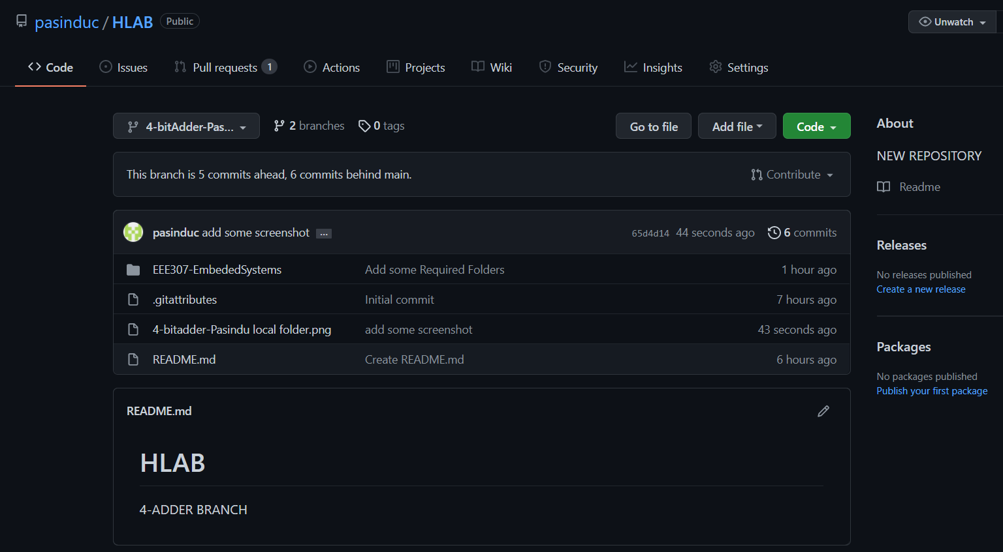

Main branch ( before add presentation file )

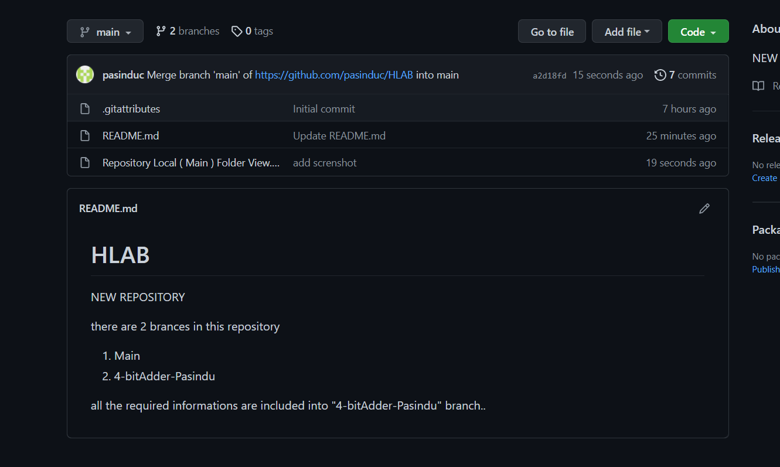

HLAB CLI : gh repo clone pasinduc/HLAB
URL FOR REPOSITORY : https://github.com/pasinduc/HLAB

Note :-

1st repository : HelloWorldLab CLI : gh repo clone pasinduc/PasinduC_HelloWorldLabs
Repository Url : https://github.com/pasinduc/PasinduC_HelloWorldLabs
( included 2 brances)

2nd repository: HLAB CLI : gh repo clone pasinduc/HLAB
URL FOR REPOSITORY : https://github.com/pasinduc/HLAB

( included 2 branches )

